Module 3
SQL DML (Data Manipulation Language), Physical Data Organization
SQL DML (Data Manipulation Language) - SQL queries on single and multiple tables, Nested queries (correlated and non-correlated), Aggregation and grouping, Views, assertions, Triggers, SQL data types.
Physical Data Organization - Review of terms: physical and logical records, blocking factor, pinned and unpinned organization. Heap files, Indexing, Singe level indices, numerical examples, Multi-level-indices, numerical examples, B-Trees & B+-Trees (structure only, algorithms not required), Extendible Hashing, Indexing on multiple keys – grid files.

1.DML(Data Manipulation Language)
The SQL commands that deal with the manipulation of data present in the database belong to DML or Data Manipulation Language and this includes most of the SQL statements. It is the component of the SQL statement that controls access to data and to the database.
List of DML commands:
- SELECT: It is used to select data from a table.
- INSERT: It is used to insert data into a table.
- UPDATE: It is used to update existing data within a table.
- DELETE: It is used to delete records from a database table.

2.SQL queries on single and multiple tables
Basic Retrieval Queries in SQL
SQL has one basic statement for retrieving information from a database; the SELECT statement. This is not the same as the SELECT operation of the relational algebra
Important distinction between SQL and the formal relational model are:
- In general, an SQL table is not a set of tuples, because a set does not allow two identical members; rather, it is a multiset (sometimes called a bag) of tuples. Ie SQL allows a table (relation) to have two or more tuples that are identical in all their attribute values.
- Some SQL relations are constrained to be sets because a key constraint has been declared or because the DISTINCT option has been used with the SELECT statement.
The SELECT-FROM-WHERE Structure of Basic SQL Queries
The basic form of the SELECT statement, sometimes called a mapping or a select-from-where block, is formed of the three clauses SELECT, FROM, and WHERE and has the following form:
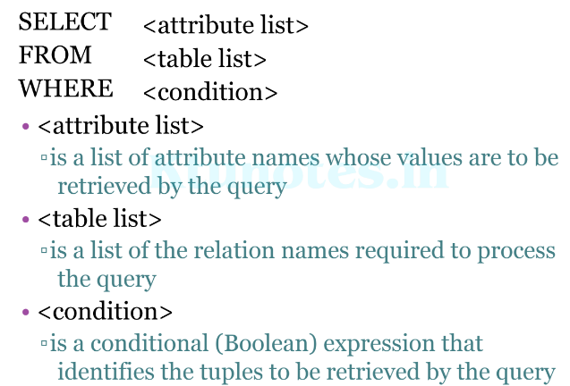
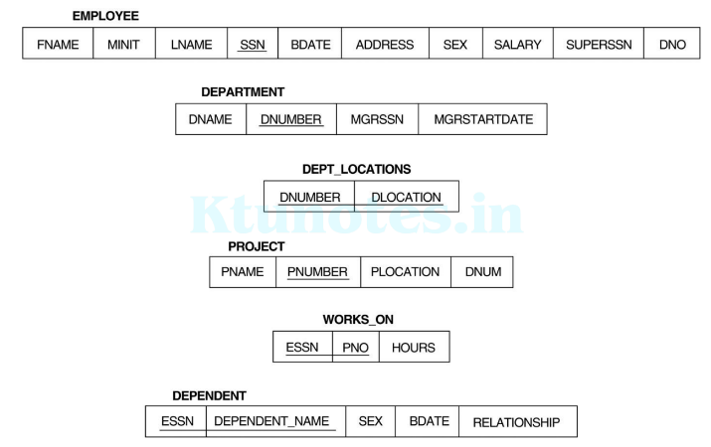
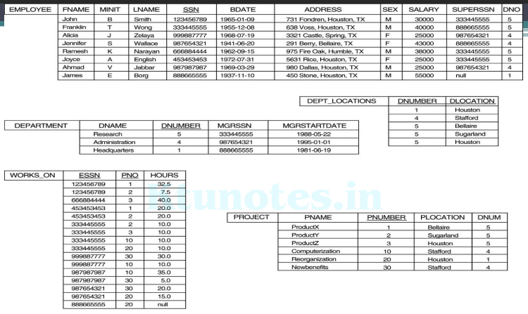
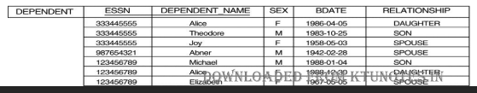
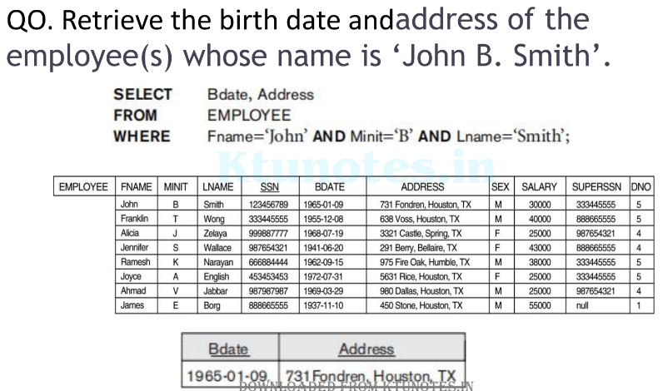
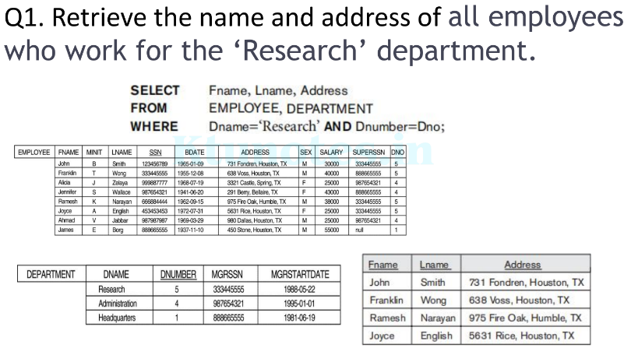
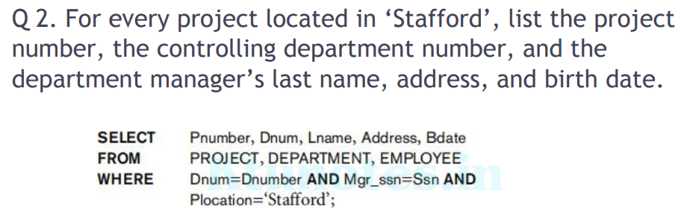
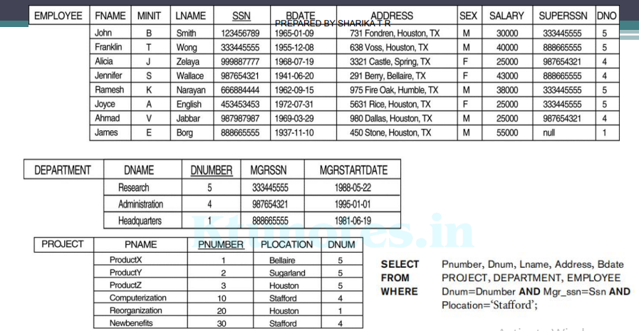
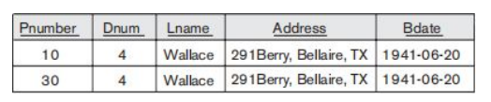
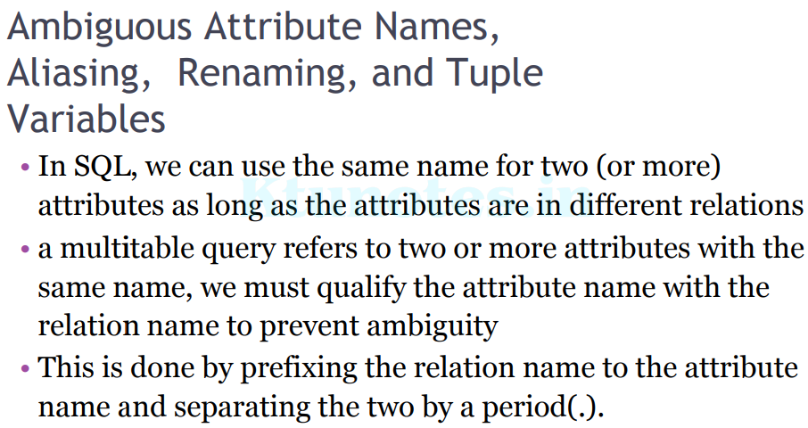
To illustrate this, suppose that the Dno and Lname attributes of the EMPLOYEE relation were called Dnumber and Name, and the Dname attribute of DEPARTMENT was also called Name; then, to prevent ambiguity, query Q1 would be rephrased as shown in Q1A.
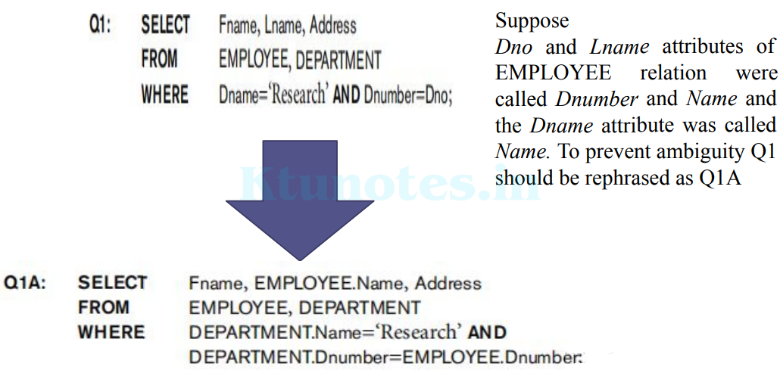
We can also create an alias for each table name to avoid repeated typing of long table names (see Q8 below).
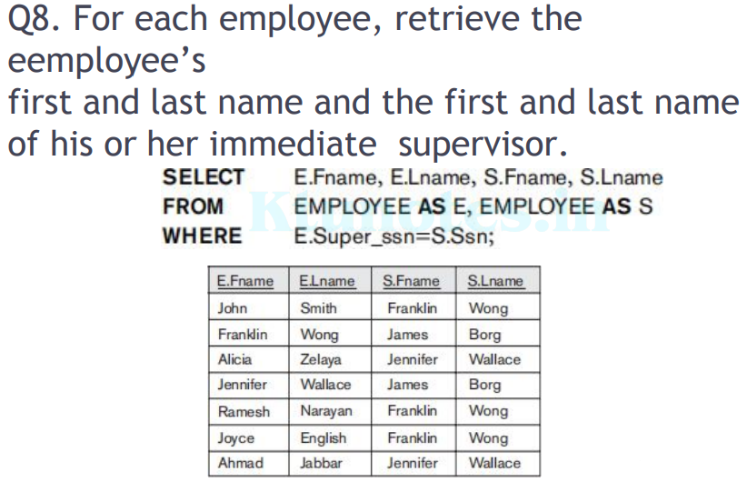
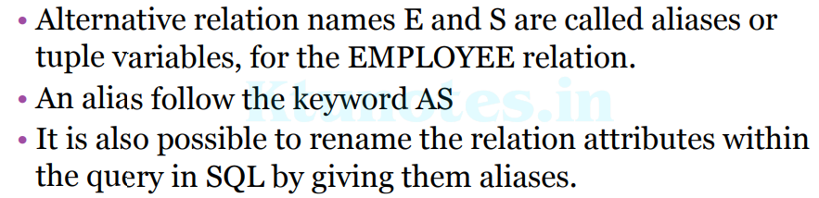
In the FROM clause, Fn becomes an alias for Fname, Mi for Minit, Ln for Lname and so on.
This is an example of a one-level recursive query.
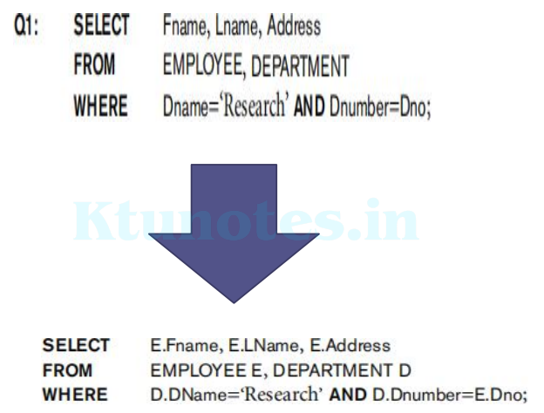

Unspecified WHERE Clause and Use of the Asterisk
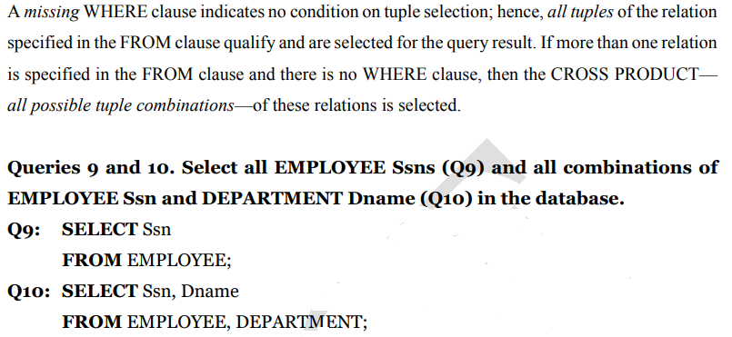
9. 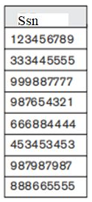 10. 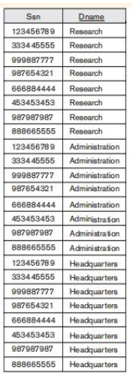
For example, query Q1C retrieves all the attribute values of any EMPLOYEE who works in DEPARTMENT number 5, query Q1D retrieves all the attributes of an EMPLOYEE and the attributes of the DEPARTMENT in which he or she works for every employee of the ‘Research’ department, and Q10A specifies the CROSS PRODUCT of the EMPLOYEE and DEPARTMENT relations.
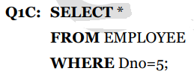
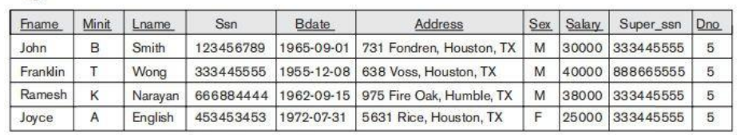
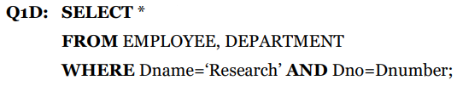
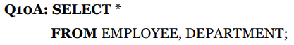
Tables as Sets in SQL
SQL usually treats a table not as a set but rather as a multiset; duplicate tuples can appear more than once in a table, and in the result of a query. SQL does not automatically eliminate duplicate tuples in the results of queries, for the following reasons:
♣ Duplicate elimination is an expensive operation. One way to implement it is to sort the tuples first and then eliminate duplicates.
♣ The user may want to see duplicate tuples in the result of a query.
♣ When an aggregate function is applied to tuples, in most cases we do not want to eliminate duplicates.
If we do want to eliminate duplicate tuples from the result of an SQL query, we use the keyword DISTINCT in the SELECT clause, meaning that only distinct tuples should remain in the result.
In general, a query with SELECT DISTINCT eliminates duplicates, whereas a query with SELECT ALL does not.
Specifying SELECT with neither ALL nor DISTINCT—as in our previous examples— is equivalent to SELECT ALL.
Q11 retrieves the salary of every employee; if several employees have the same salary, that salary value will appear as many times in the result of the query.
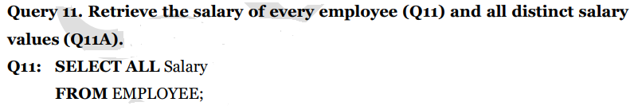
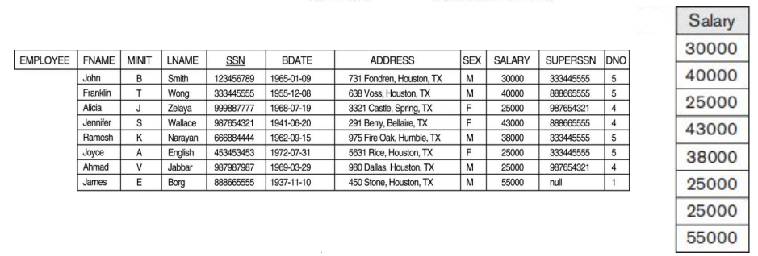
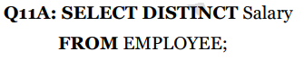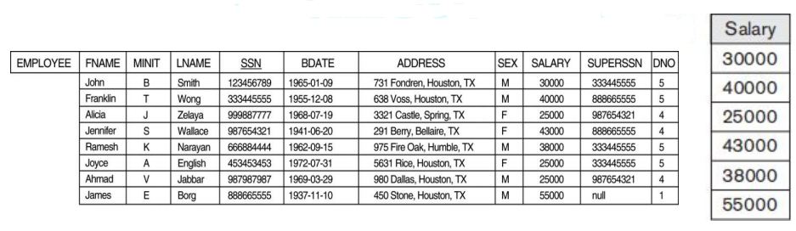
SQL has directly incorporated some of the set operations from mathematical set theory, which are also part of relational algebra. There are set union (UNION), set difference (EXCEPT), and set intersection (INTERSECT) operations. The relations resulting from these set operations are sets of tuples; that is, duplicate tuples are eliminated from the result. These set operations apply only to union-compatible relations, so we must make sure that the two relations on which we apply the operation have the same attributes and that the attributes appear in the same order in both relations.
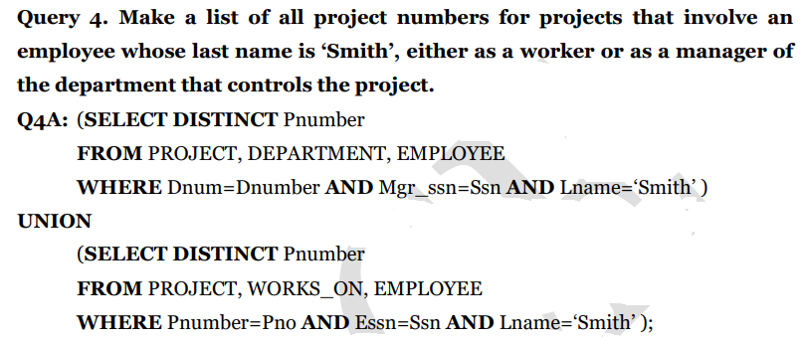
The first SELECT query retrieves the projects that involve a ‘Smith’ as manager of the department that controls the project, and the second retrieves the projects that involve a ‘Smith’ as a worker on the project. Notice that if several employees have the last name ‘Smith’, the project names involving any of them will be retrieved. Applying the UNION operation to the two SELECT queries gives the desired result.
SQL also has corresponding multiset operations, which are followed by the keyword ALL (UNION ALL, EXCEPT ALL, INTERSECT ALL). Their results are multisets (duplicates are not eliminated).
UNION ALL
• The UNION ALL command combines the result set of two or more SELECT statements (allows duplicate values).
• The following SQL statement returns the supplier_id (duplicate values also) from both the "Customers" and the "Suppliers" table:
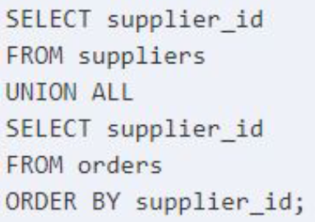
This SQL UNION ALL example would return the supplier_id multiple times in the result set if that same value appeared in both the suppliers and orders table.
The SQL UNION ALL operator does not remove duplicates. If you wish to remove duplicates, try using the UNION operator.
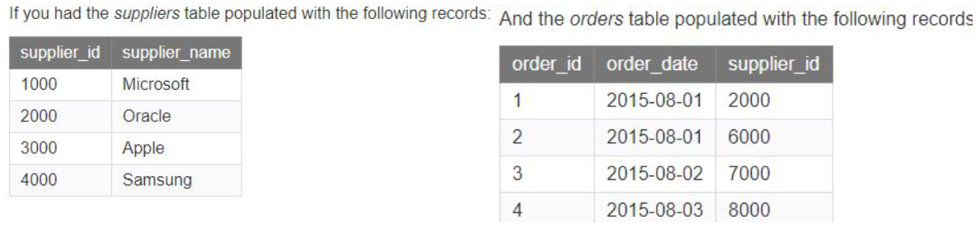
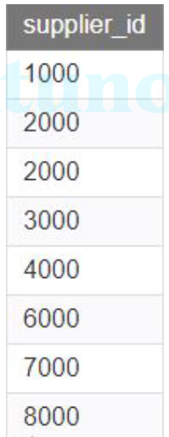
INTERSECT Operator
• INTERSECT operator is used to return the records that are in common between two SELECT statements or data sets.
• If a record exists in one query and not in the other, it will be omitted from the INTERSECT results.
• It is the intersection of the two SELECT statements.
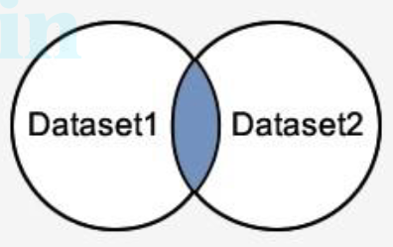
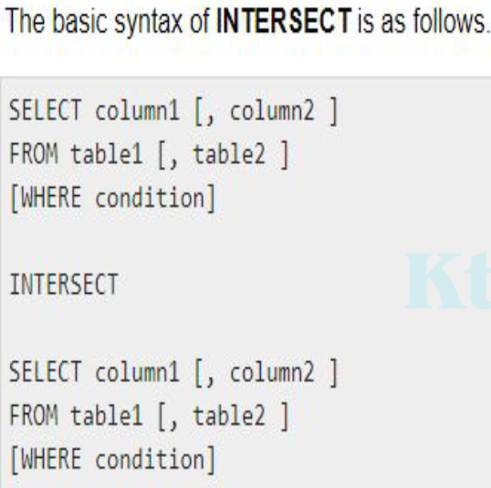
EXCEPT
• The SQL EXCEPT clause/operator is used to combine two SELECT statements and returns rows from the first SELECT statement that are not returned by the second SELECT statement.
▫ This means EXCEPT returns only rows, which are not available in the second SELECT statement.
• Just as with the UNION operator, the same rules apply when using the EXCEPT operator.
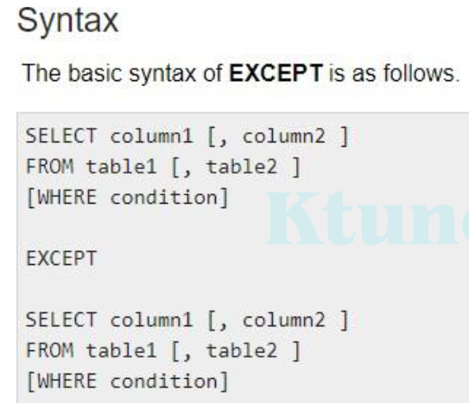
Substring Pattern Matching and Arithmetic Operators
The first feature allows comparison conditions on only parts of a character string, using the LIKE comparison operator. This can be used for string pattern matching. Partial strings are specified using two reserved characters: % replaces an arbitrary number of zero or more characters, and the underscore (_) replaces a single character.
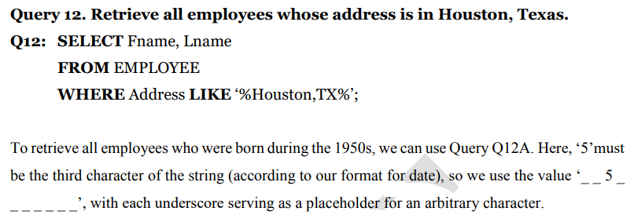
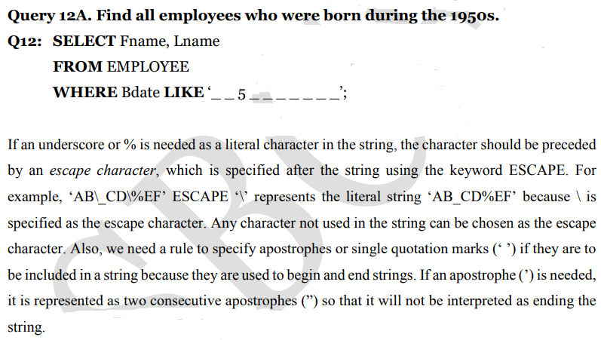
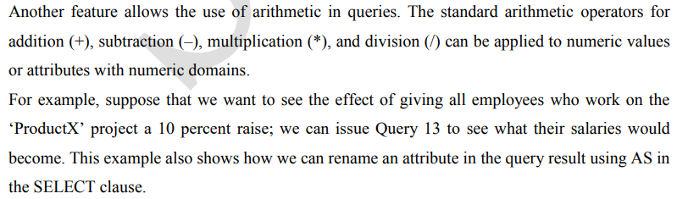
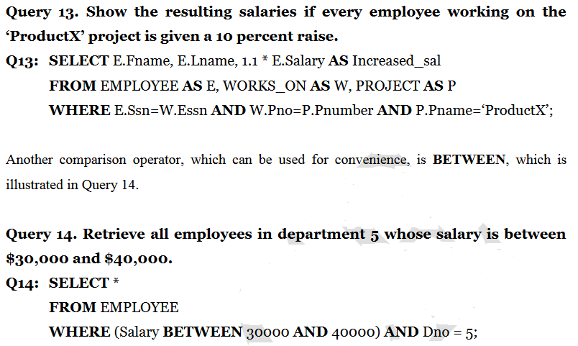
Ordering of Query Results
The ORDER BY statement in sql is used to sort the fetched data in either ascending or descending according to one or more columns.
By default ORDER BY sorts the data in ascending order.
▫ We can use the keyword DESC to sort the data in descending order and the keyword ASC to sort in ascending order.
Q. Fetch all data from the table Student and sort the result in ascending order according to the column ROLL_NO
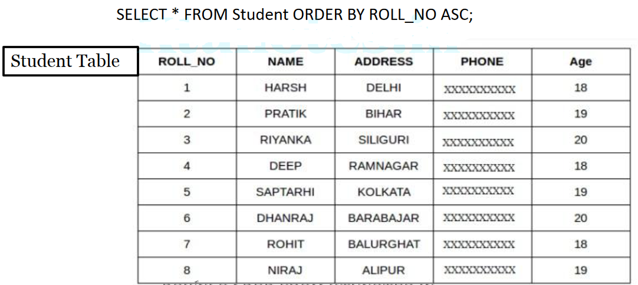
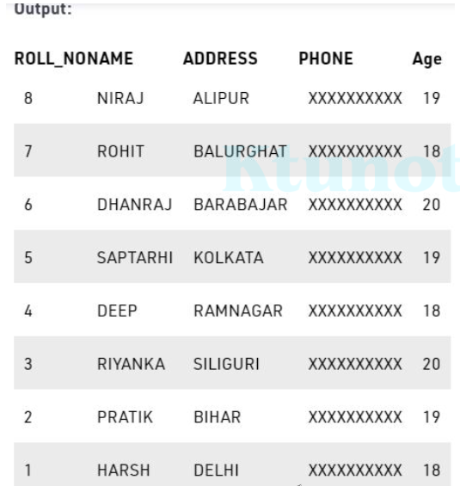
Sort according to multiple columns
Q. Fetch all data from the table Student and then sort the result in ascending order first according to the column Age. and then in descending order according to the column ROLL_NO.
Output
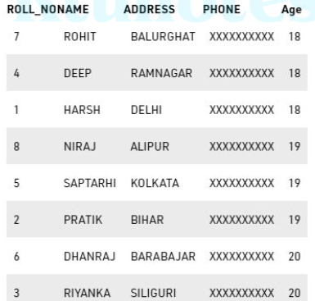
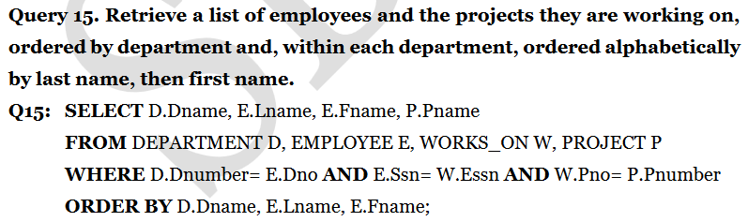
if we want descending alphabetical order on Dname and ascending order on Lname, Fname, the ORDER BY clause of Q15 can be written as

More Complex SQL Retrieval Queries
Comparisons Involving NULL
SQL has various rules for dealing with NULL values. NULL is used to represent a missing value, but that it usually has one of three different interpretations—value unknown (exists but is not known), value not available (exists but is purposely withheld), or value not applicable (the attribute is undefined for this tuple).
1. Unknown value -A person’s date of birth is not known, so it is represented by NULL in the database.
2. Unavailable or withheld value - A person has a home phone but does not want it to be listed, so it is withheld and represented as NULL in the database.
3. Not applicable attribute - An attribute LastCollegeDegree would be NULL for a person who has no college degrees because it does not apply to that person.
SQL allows queries that check whether an attribute value is NULL. Rather than using = or <> to compare an attribute value to NULL, SQL uses the comparison operators IS or IS NOT.
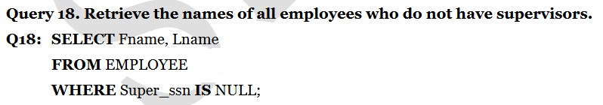
Nested Queries, Tuples, and Set/Multiset Comparisons
Some queries require that existing values in the database be fetched and then used in a comparison condition. Such queries can be conveniently formulated by using nested queries, which are complete select-from-where blocks within the WHERE clause of another query. That other query is called the outer query.
A complete SELECT query, called a nested query , can be specified within the WHERE-clause of another query, called the outer query.
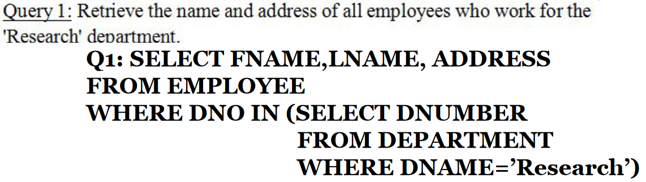
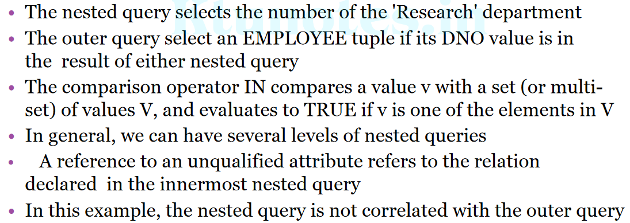
Q. Return the names of employees whose salary is greater than the salary of all the employees from department number 5.
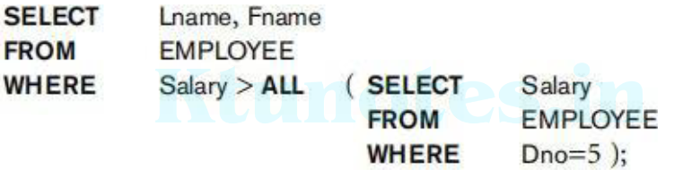
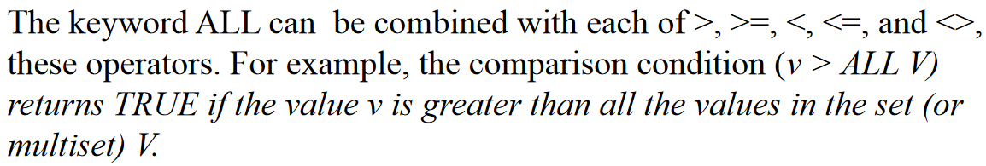
SQL allows the use of tuples of values in comparisons by placing them within parentheses. Toillustrate this, consider the following query:
Q. Select the Essn of all employees who work in the same (project, hours)combination on some project that employee ‘John Smith’ (whose Ssn =‘123456789’) works on.
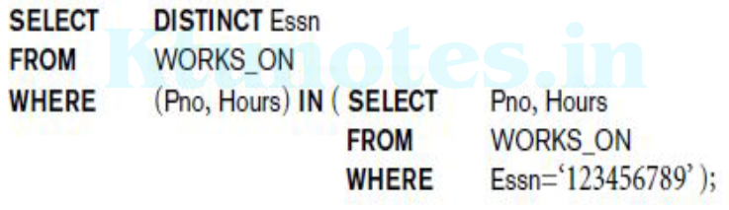
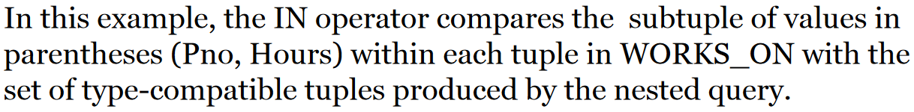
Q16. Retrieve the name of each employee who has a dependent with the same first name and is the same sex as the employee.
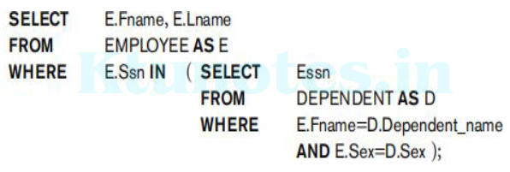
Q. The first nested query selects the project numbers of projects that have an employee with last name ‘Smith’ involved as manager, while the second nested query selects the project numbers of projects that have an employee with last name ‘Smith’ involved as worker. In the outer query, we use the OR logical connective to retrieve a PROJECT tuple if the PNUMBER value of that tuple is in the result of either nested query.
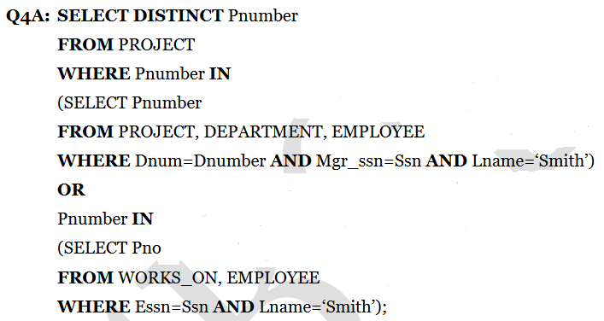
Correlated Nested Queries
Whenever a condition in the WHERE clause of a nested query references some attribute of a relation declared in the outer query, the two queries are said to be correlated. The result of a correlated nested query is different for each tuple (or combination of tuples) of the relation(s) the outer query. For example we can think of Q16 as follows: For each EMPLOYEE tuple, evaluate the nested query, which retrieves the Essn values for all DEPENDENT tuples with the same sex and name as that EMPLOYEE tuple; if the Ssn value of the EMPLOYEE tuple is in the result of the nested query, then select that EMPLOYEE tuple.
In correlated subquery, inner query is dependent on the outer query. Outer query needs to be executed before inner query. They are slower qeries.
In non-correlated subquery, inner query does not dependent on the outer query. They both can run separately. They are faster than correlated subqueries.
The EXISTS and UNIQUE Functions in SQL
EXISTS function in SQL is used to check whether the result of a correlated nested query is empty (contains no tuples) or not.
• The result of EXISTS is a Boolean value
▫TRUE if the nested query result contains at least one tuple, or
▫FALSE if the nested query result contains no tuples.

Q.Retrieve the name of each employee who has a dependent with the same sex as the employee.
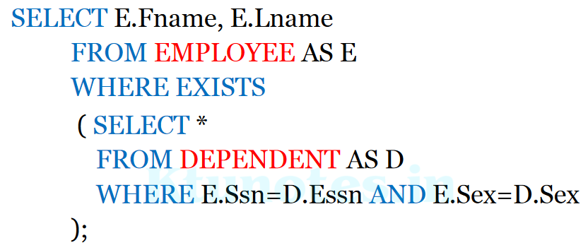
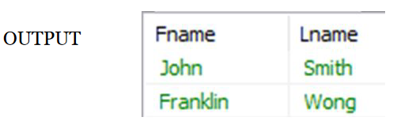
Answer is TRUE
Here Fname and Lname from EMPLOYEE table is taken and check it to see whether E.Ssn=D.Essn AND E.Sex= D.Sex.
But for 16B answer is FALSE
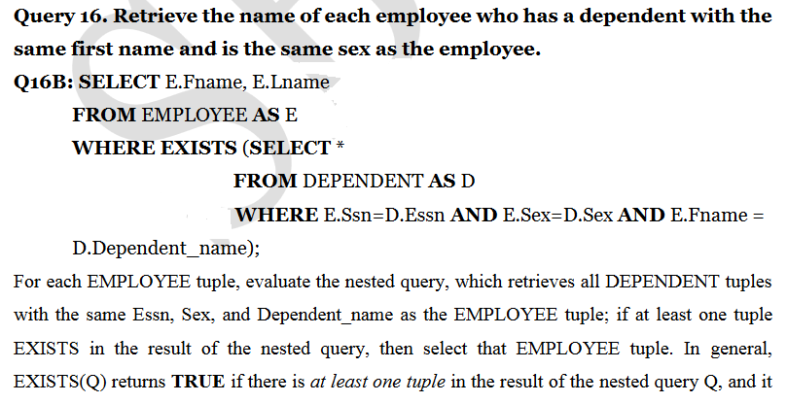
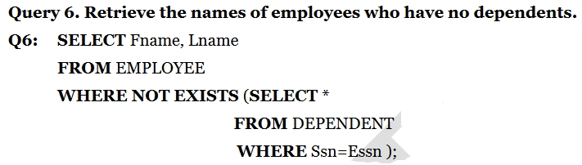
Here John Smith, Franklin Wong and Jennifer Wallace have Ssn=Essn. ie they have dependents. But here we use NOT EXISTS. So we retrieve names of all other employees.
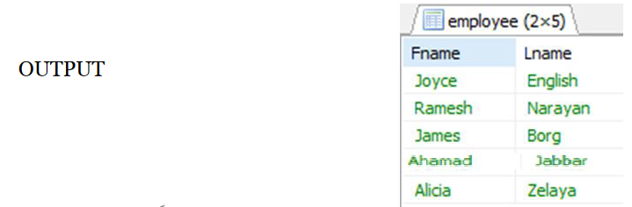
Explicit Sets in SQL
It is also possible to use an explicit set of values in the WHERE clause, rather than a nested query. Such a set is enclosed in parentheses in SQL.
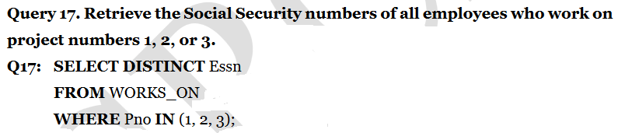
Joined Tables in SQL
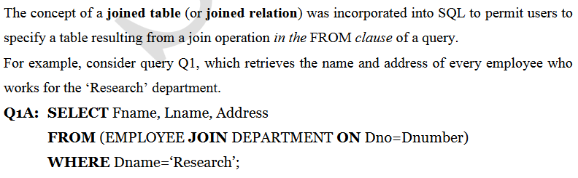
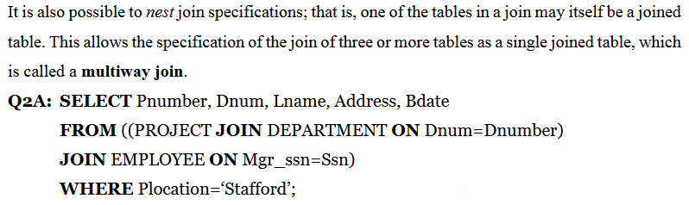
Aggregate Functions in SQL
- Aggregate functions are used to summarize information from multiple tuples into a single-tuple summary.
- Grouping is used to create sub-groups of tuples before summarization.
A number of built-in aggregate functions exist:
1. COUNT
2. SUM
3. MAX
4. MIN
and 5. AVG
- COUNT function returns the number of tuples or values as specified in a query.
- The functions SUM, MAX, MIN, and AVG can be applied to a set or multiset of numeric values and return, respectively, the sum, maximum value, minimum value, and average (mean) of those values.
- These functions can be used in the SELECT clause or in a HAVING clause.

Q19. Find the sum of the salaries of all employees, the maximum salary, the minimum salary, and the average salary.
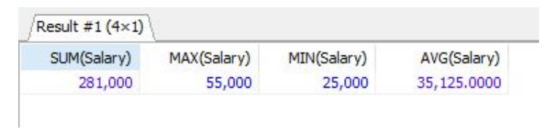
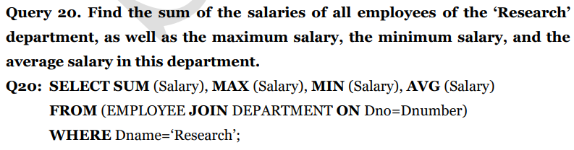
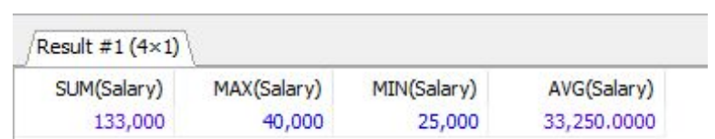

Q21. Retrieve the total number of employees in the company
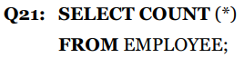
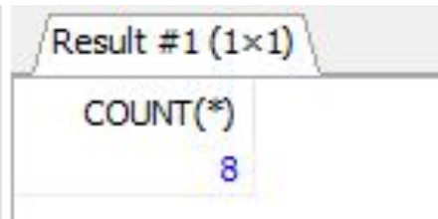
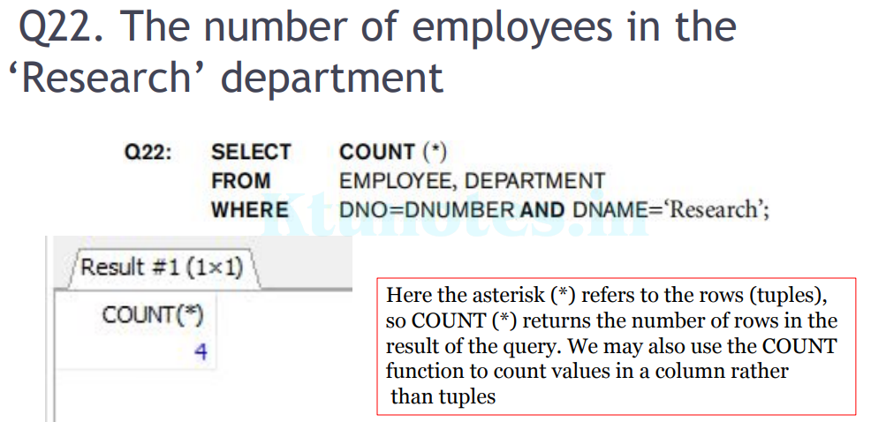
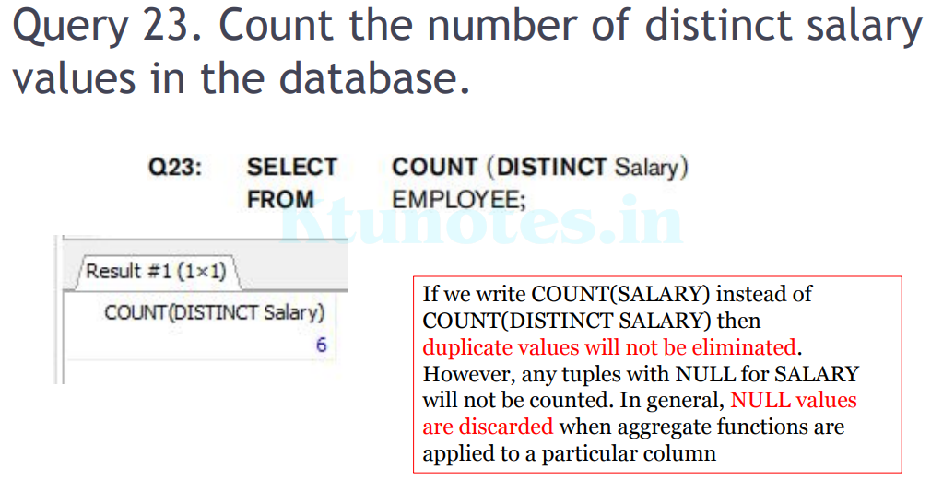
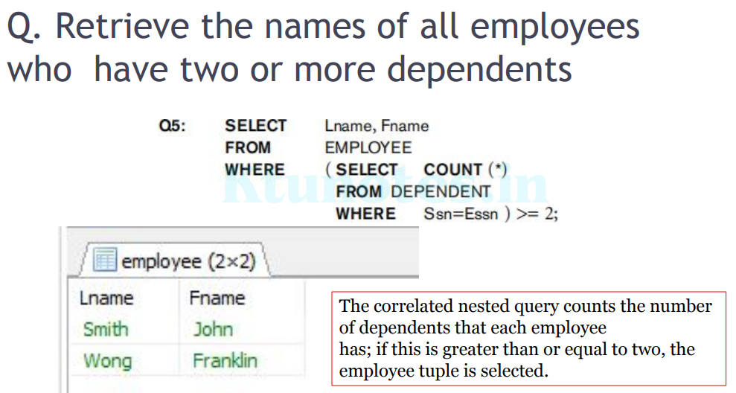

Grouping: The GROUP BY and HAVING Clauses
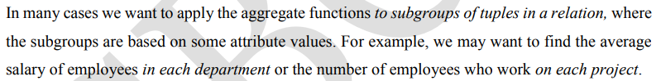
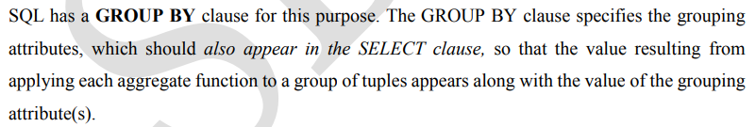
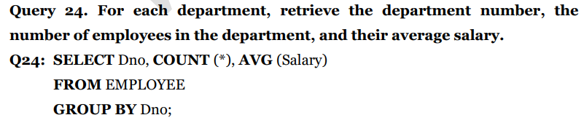
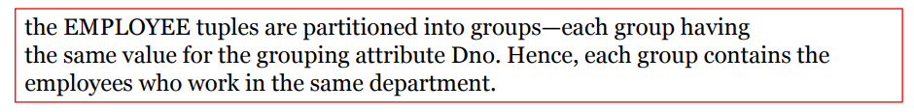
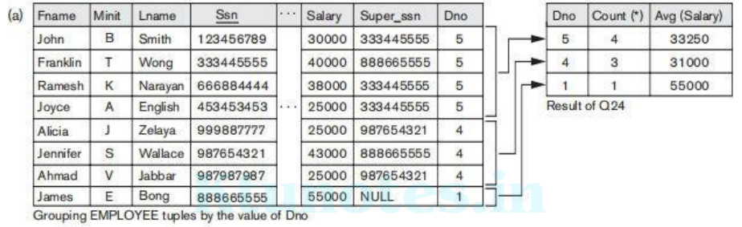
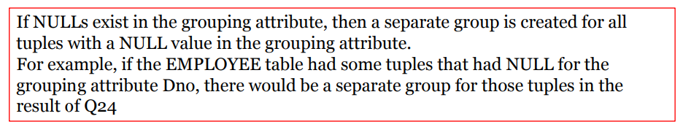
Query 25. For each project, retrieve the project number, the project name, and the number of employees who work on that project.
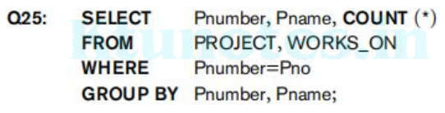
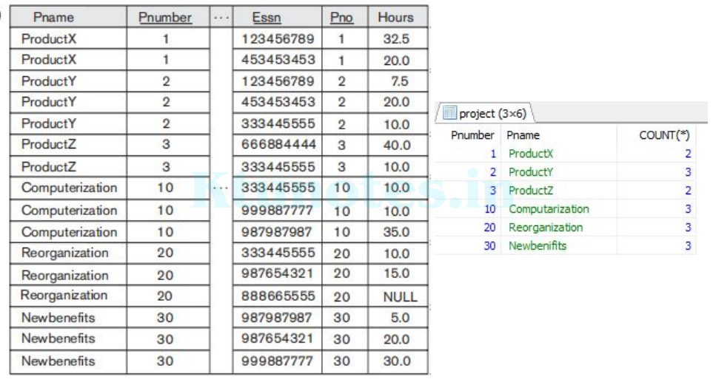
HAVING clause
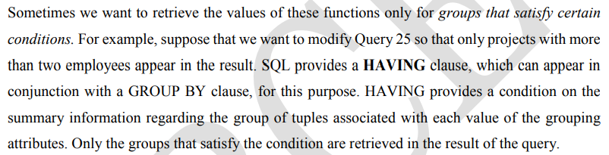
Q 26. For each project on which more than two employees work, retrieve the project number, the project name, and the number of employees who work on the project.
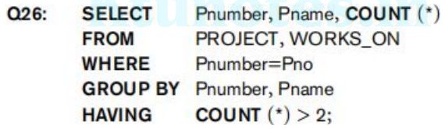
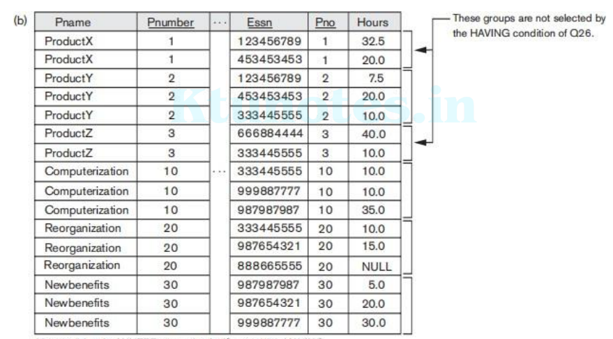
Fig:After applying the WHERE clause but before applying HAVING
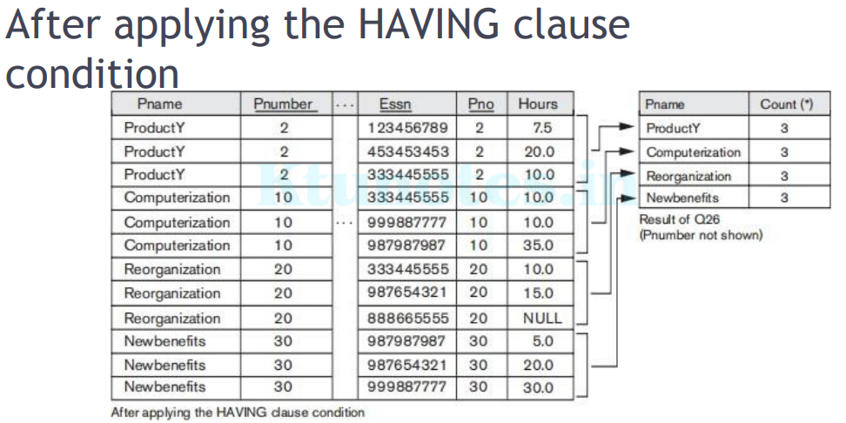
In GROUP BY the grouping and functions are applied after the joining of the two relations.
• Sometimes we want to retrieve the values of these functions only for groups that satisfy certain conditions
• HAVING clause, which can appear in conjunction with a GROUP BY clause
• HAVING provides a condition on the summary information regarding the group of tuples associated with each value of the grouping attributes.
• Only the groups that satisfy the condition are retrieved in the result of the query.
Query 27. For each project, retrieve the project number, the project name, and the number of employees from department 5 who work on the project.
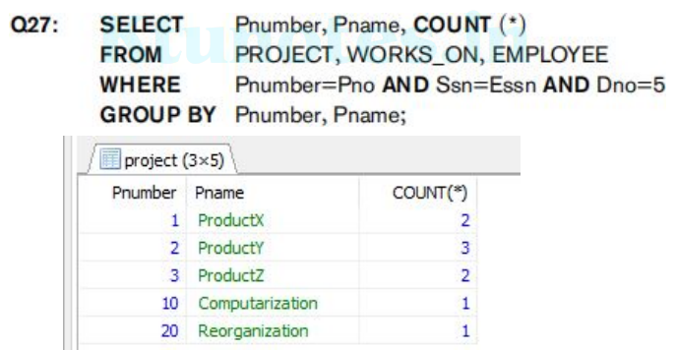
Specifying Constraints as Assertions and Actions as Triggers
Specifying General Constraints as Assertions in SQL
Assertions = conditions that the database must always satisfy
• Domain constraints and referential-integrity constraints are specific forms of assertions
• CHECK – verify the assertion on one-table, one-attribute
• ASSERTION – verify one or more tables, one or more attributes
• Some constraints cannot be expressed by using only domain constraints or referential-integrity constraints; for example,
▫ “Every department must have at least five courses offered every semester” – must be expressed as an assertion.
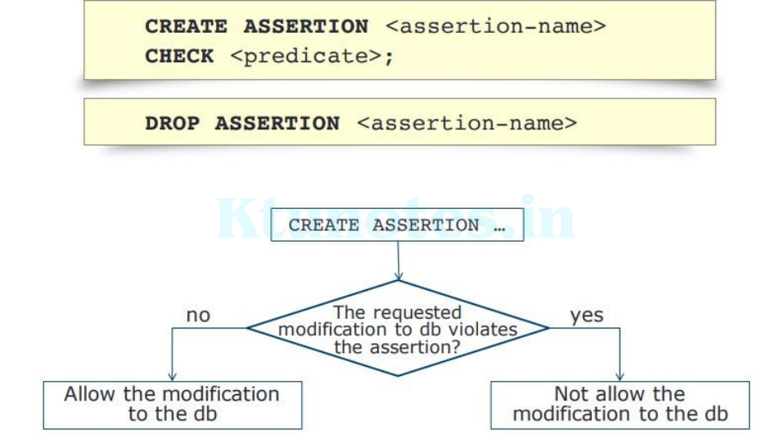
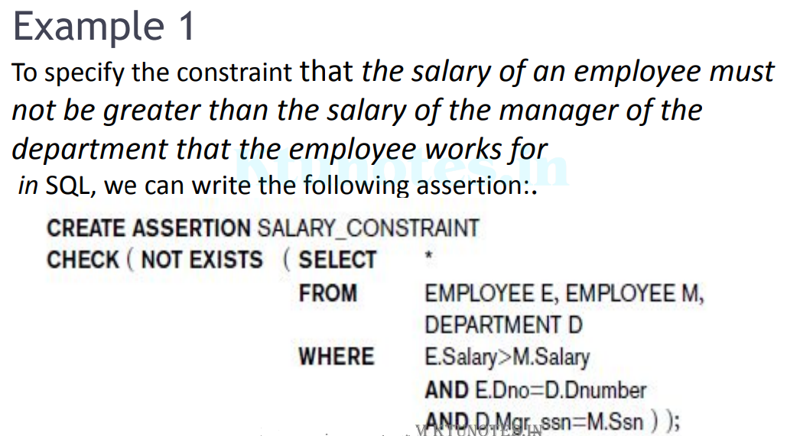
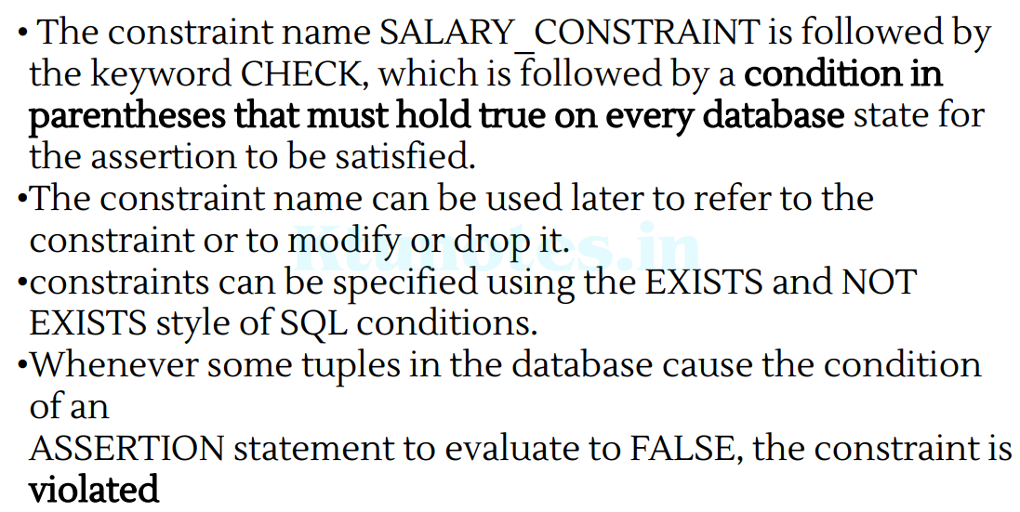
Introduction to Triggers in SQL
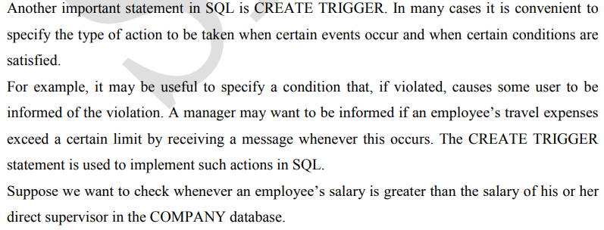
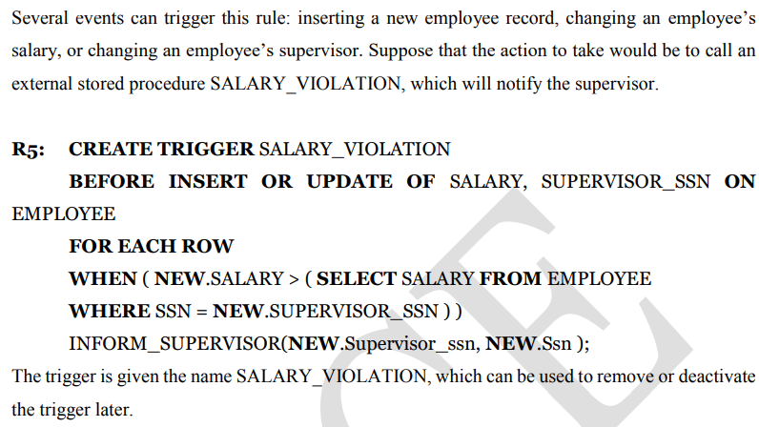
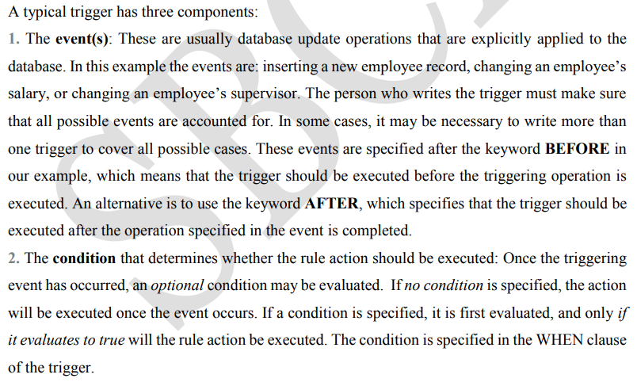
3. The action to be taken: The action is usually a sequence of SQL statements, but it could also be a database transaction or an external program that will be automatically executed. In this example, the action is to execute the stored procedure INFORM_SUPERVISOR.
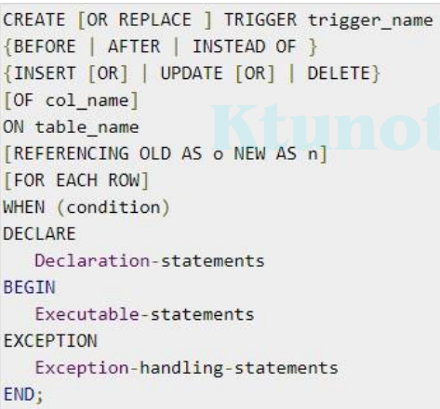
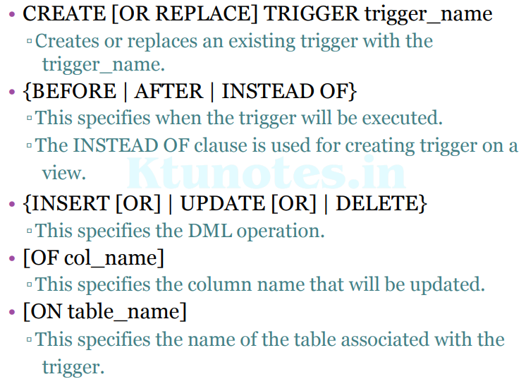
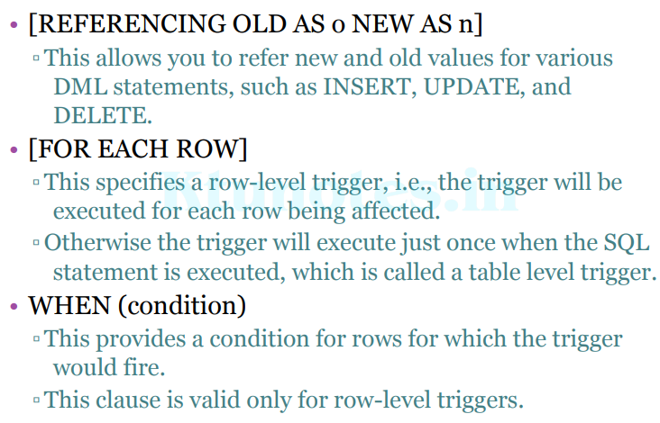
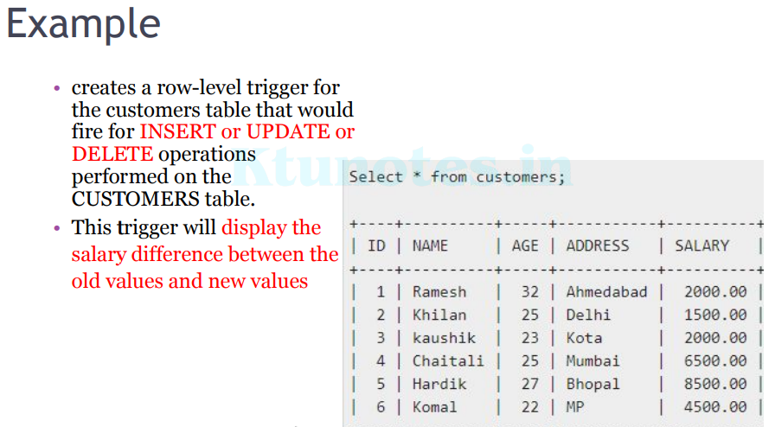
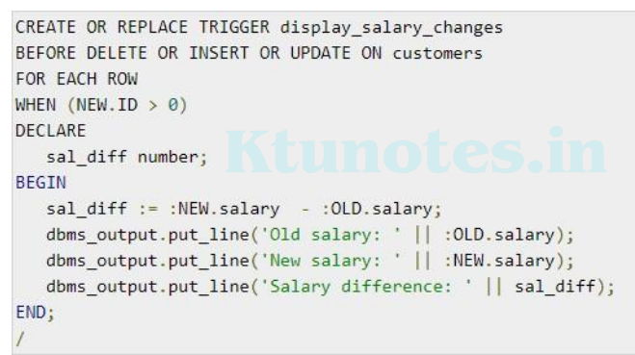
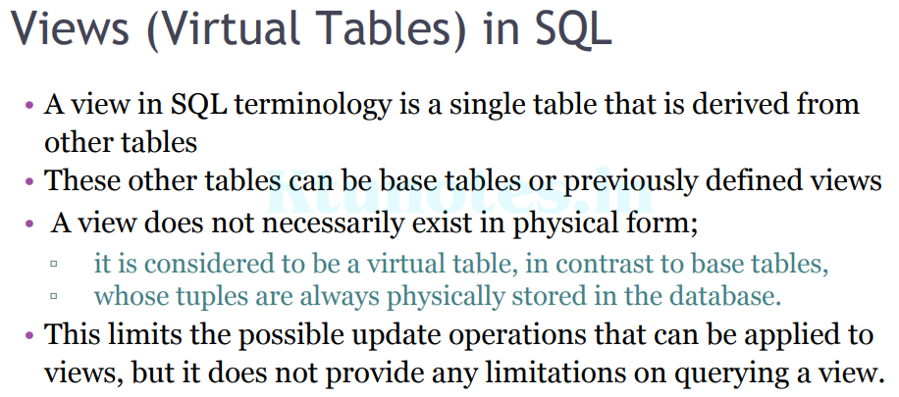
We can think of a view as a way of specifying a table that we need to reference frequently, even though it may not exist physically.
• Views, which are a type of virtual tables allow users to do the following
▫Structure data in a way that users or classes of users find natural or intuitive.
▫Restrict access to the data in such a way that a user can see and (sometimes) modify exactly what they need and no more.
▫Summarize data from various tables which can be used to generate reports.
Specification of Views in SQL
- In SQL, the command to specify a view is CREATE VIEW.
- The view is given a (virtual) table name (or view name), a list of attribute names, and a query to specify the contents of the view.
- If none of the view attributes results from applying functions or arithmetic operations,
▫ we do not have to specify new attribute names for the view, since they would be the same as the names of the attributes of the defining tables in the default case.
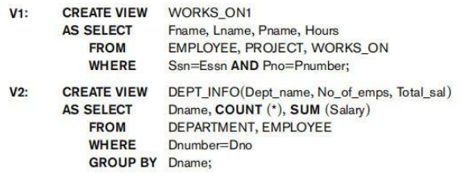
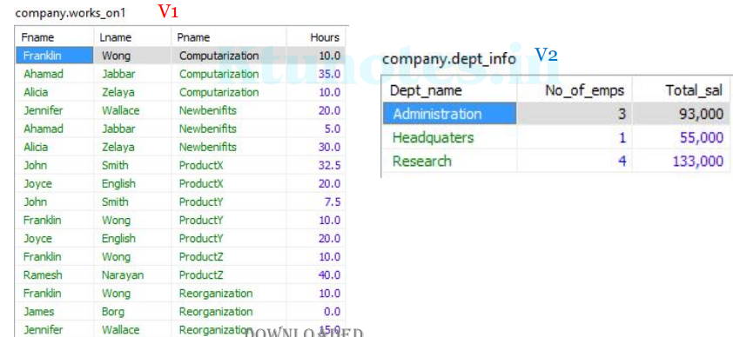
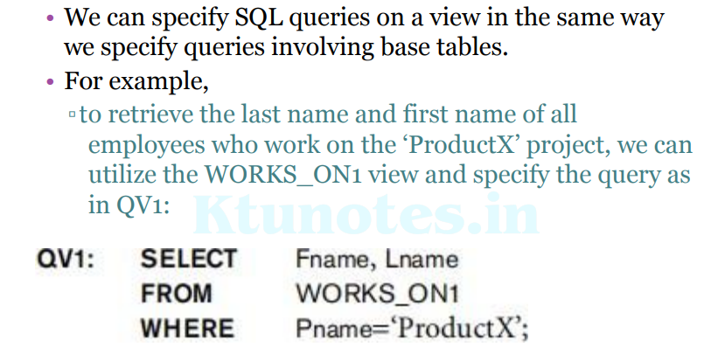
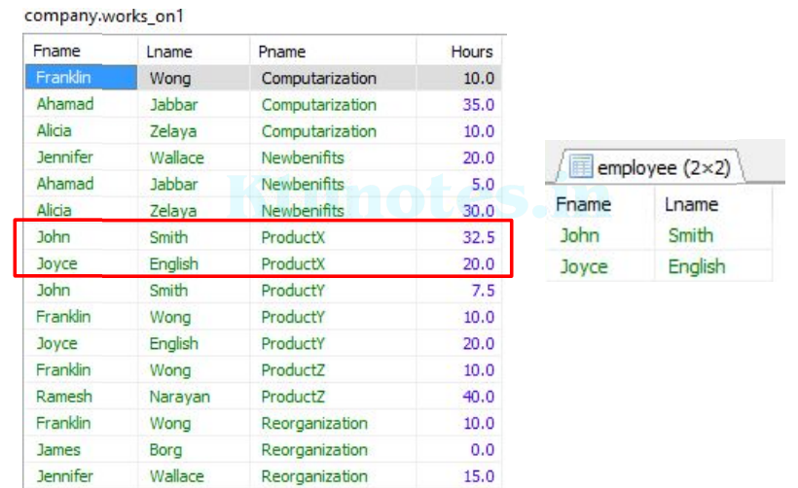
• A view is supposed to be always up-to-date; ▫ if we modify the tuples in the base tables on which the view is defined, the view must automatically reflect these changes.
• Hence, the view is not realized or materialized at the time of view definition but rather at the time when we specify a query on the view.
• It is the responsibility of the DBMS and not the user to make sure that the view is kept up-to-date.
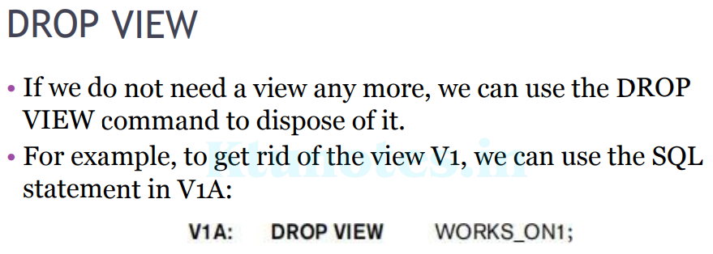
View Implementation, View Update, and Inline Views
The problem of efficiently implementing a view for querying is complex. Two main approaches have been suggested. One strategy, called query modification, involves modifying or transforming the view query (submitted by the user) into a query on the underlying base tables. For example, the query QV1 would be automatically modified to the following query by the DBMS:
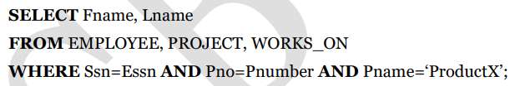
The disadvantage of this approach is that it is inefficient for views defined via complex queries that are time-consuming to execute, especially if multiple queries are going to be applied to the same view within a short period of time.
The second strategy, called view materialization, involves physically creating a temporary view table when the view is first queried and keeping that table on the assumption that other queries on the view will follow. In this case, an efficient strategy for automatically updating the view table when the base tables are updated must be developed in order to keep the view up-to-date.
• Techniques using the concept of incremental update have been developed for this purpose,
▫ where the DBMS can determine what new tuples must be inserted, deleted, or modified in a materialized view table when a database update is applied to one of the defining base tables.
- The view is generally kept as a materialized (physically stored) table as long as it is being queried.
- If the view is not queried for a certain period of time, the system may then automatically remove the physical table and recompute it from scratch when future queries reference the view.
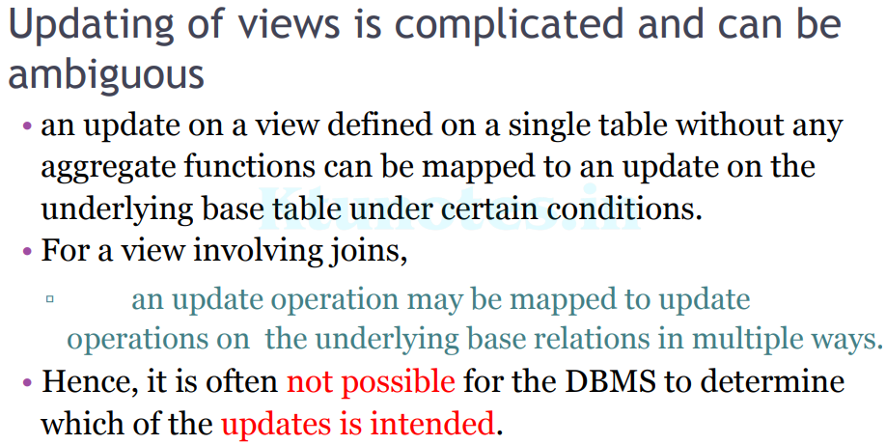
♣ A view with a single defining table is updatable if the view attributes contain the primary key of the base relation, as well as all attributes with the NOT NULL constraint that do not have default values specified.
♣ Views defined on multiple tables using joins are generally not updatable.
♣ Views defined using grouping and aggregate functions are not updatable. It is also possible to define a view table in the FROM clause of an SQL query. This is known as an in-line view. In this case, the view is defined within the query itself.
Physical Data Organization

